Mobile App Development

CSE-4078

Lab Plan 3

# Objective:

* To be able to understand the use of stateless widgets
* To be able to import custom fonts in Flutter
* To be able to use different container widgets to design a simple app in Flutter

# Course Learning Outcome (CLO):

* **CLO-2:** Demonstrate the knowledge of Flutter to design stateful, cross-platform, and interactive user interfaces for mobile applications.

# Lab Tasks

1. Modify the Lab 2, Task 1 (the UI of the task is given below) by eliminating the code in runApp() method and creating a stateless widget. Note: Your entire code can be re-used in this task.

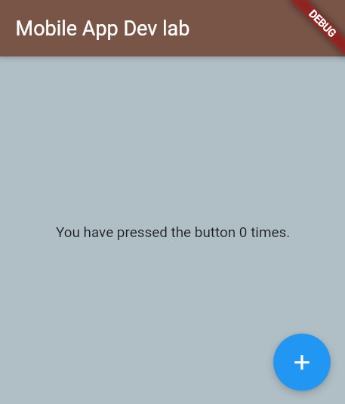

1. Create a contact-card app that shows your contact details as given in following figure. The components and requirements of this app are given below.
   1. Include safe area
   2. Grey background
   3. Contain a circular avatar with an image, and 50 radius.
   4. Your name with following style guidelines
      1. Font ZenKurenaido (custom Google font)
      2. Bold
      3. White Color
      4. Font size 30
   5. Your Designation with following style guidelines
      1. Font Lato (custom Google font)
      2. Bold
      3. White Color
      4. Font size 20
      5. Letter spacing 3
   6. Phone icon and contact number with grey color, white background, padding, and margin
   7. Email icon and email with grey color, white background, padding, and margin

